LAB 3

\* Create a Simple maven Project and then create a class:

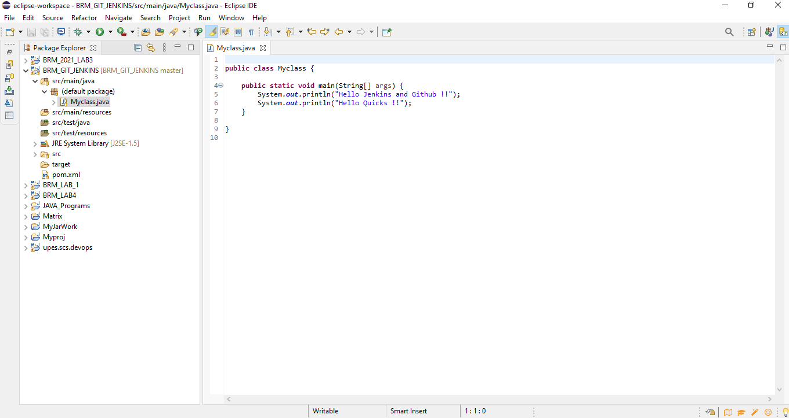

\* Commit and Push into Github 🡪

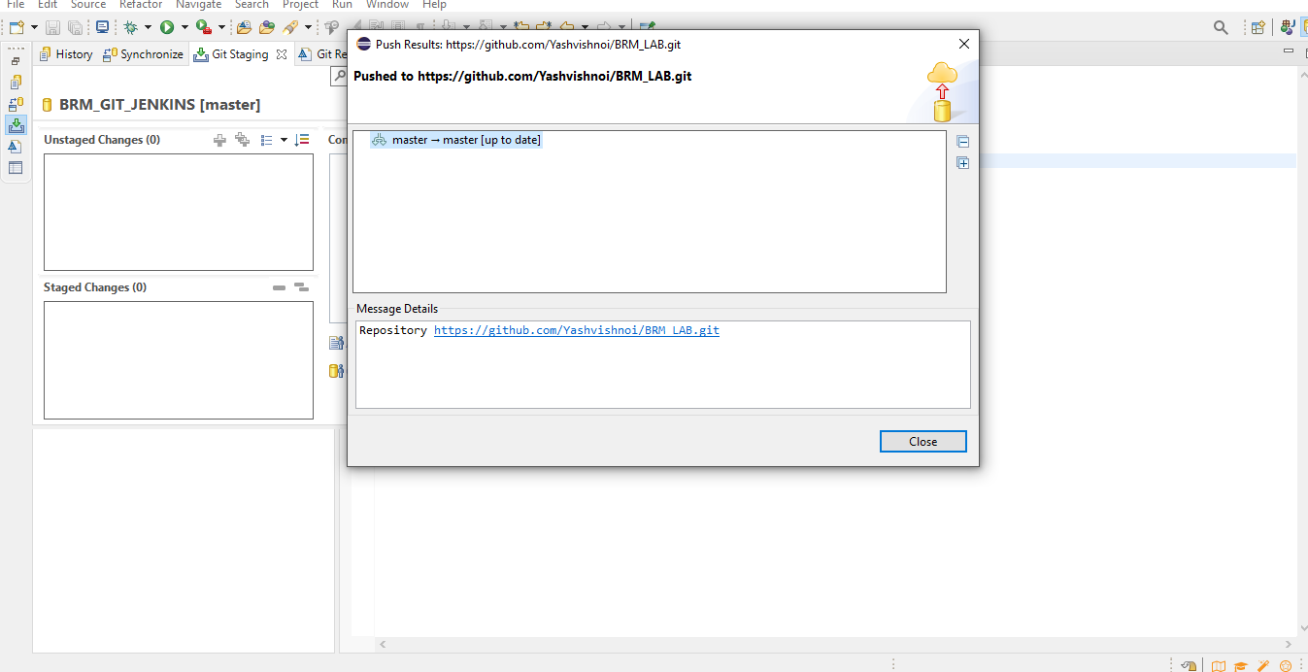

\* 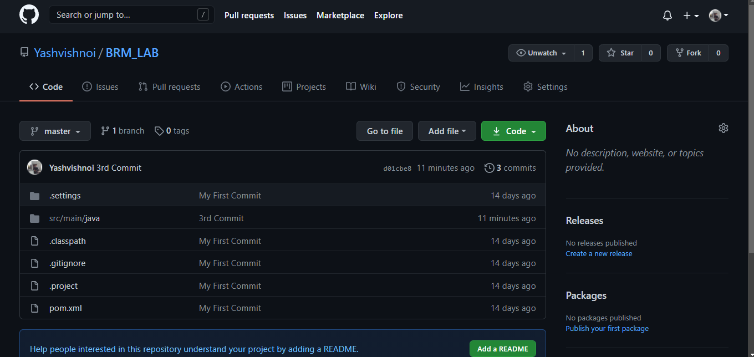

\* Open Jenkins and run goals:

\* Clean🡪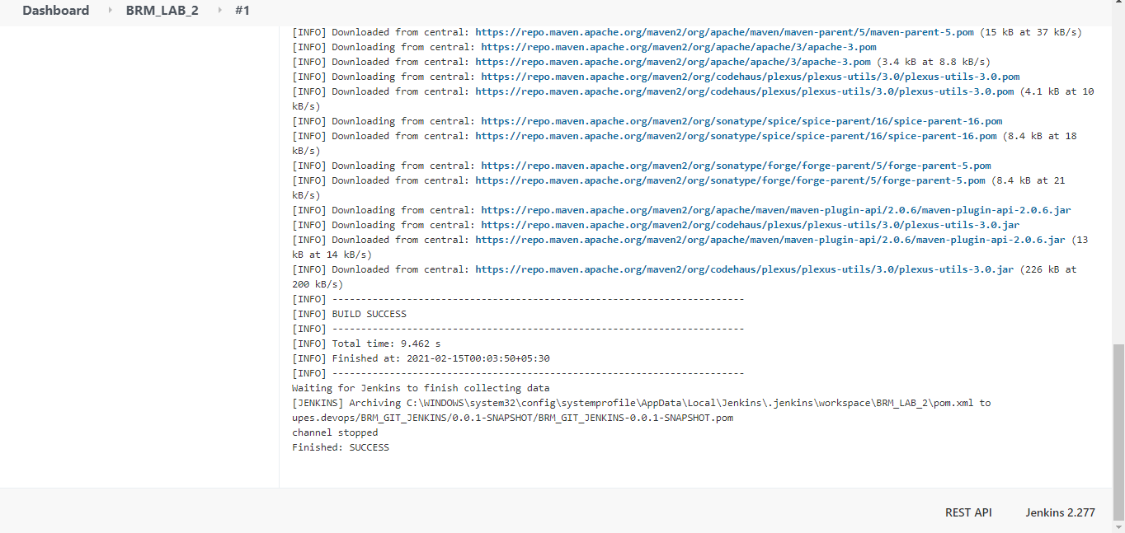

\* Install🡪

